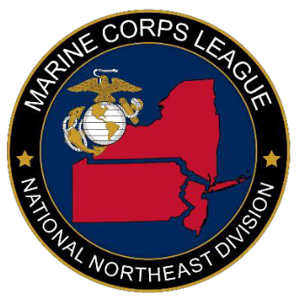
MARINE CORPS LEAGUE
NATIONAL NORTHEAST DIVISION CONFERENCE
June 4-5, 2021
Holiday Inn Harrisburg/Hershey I-81
604 Station Road
Grantville, PA17028

REGISTRATION/BANQUET FORM

Date:

Name:

Detachment/Unit:

Office/Title:

Address:

City, State, Zip:

Phone: E-Mail:

Conference Pre-Registration is $8.00 per person. Count X $8.00 = (Registration at Conference will be $10.00)
Banquet ticket $40.00 per person Count X $40.00 =

Total $

Make checks payable to: MCL of PA, Inc

On memo line state: Northeast Div. Conference

Send to: (Email address required for receipt)
Northeast Division Conference
Attn: NE Division Paymaster
P.O. Box 6687
Harrisburg, PA 17112

DEADLINE FOR REGISTRATION AND BANQUET: May 4, 2021

