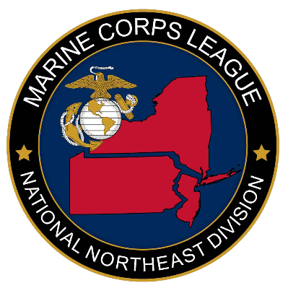
MARINE CORPS LEAGUE
NATIONAL NORTHEAST DIVISION CONFERENCE
June 4-5, 2021
Holiday Inn Harrisburg/Hershey I-81
604 Station Road
Grantville, PA17028

ADVERTISING CONTRACT

Date: 3 March 2021

You are hereby authorized to publish our/my advertisement in your publication as a Full Page 8x10 page per copy and instructions shown below.

Full Page (8x10) ........................................... $100.00
½ Page (8x5) .................................................... $60.00
¼ Page (4x5) .................................................... $40.00

Please type, copy, or send camera ready ad.
Electronic copy can be emailed to: mclpaconvention@gmail.com
Note: Ad will not be included in book without payment.

Name of Advertiser _______________________________
Address _________________________________________
City _________,___________State___NJ____Zip _________
Phone _________________ Email: ________________

Make checks payable to: Dept. of PA, MCL
On memo line state Northeast Division Conference and send to:
(Email address required for receipt)

Northeast Division Conference
Attn: NE Division Paymaster
P.O. Box 6687
Harrisburg, PA 17112

VERBAL AGREEMENTS NOT ACCEPTED OR RECOGNIZED

DEADLINE FOR ADS: April 30, 2021

